**Class:** Final Year (Computer Science and Engineering)

**Year:** 2022-23 **Semester:** 1

**Course:** High Performance Computing Lab

**Practical No. 8**

**Exam Seat No: 2019BTECS00037**

**Title of practical: Study of MPI**

**Problem Statement 1: Study and implement 2D Convolution using MPI. Use a different number of processes and analyze the performance.**

**#include <stdio.h>**

**#include <stdlib.h>**

**#include <assert.h>**

**#include <string.h>**

**#include <sys/time.h>**

**#include <mpi.h>**

**#define DEFAULT_ITERATIONS 1**

**int conv_column(int *, int, int, int, int *, int);**

**int conv(int *, int, int, int, int *, int);**

**int * check(int *, int, int, int *, int);**

**int conv_column(int * sub_grid, int i, int nrows, int DIM, int * kernel, int kernel_dim) {**

**int counter = 0;**

**int num_pads = (kernel_dim - 1) / 2;**

**for (int j = 1; j < (num_pads + 1); j++) {**

**counter = counter + sub_grid[i + j*DIM] * kernel[(((kernel_dim - 1)*(kernel_dim + 1)) / 2) + j*kernel_dim];**

**counter = counter + sub_grid[i - j*DIM] * kernel[(((kernel_dim - 1)*(kernel_dim + 1)) / 2) - j*kernel_dim];**

**}**

**counter = counter + sub_grid[i] * kernel[(((kernel_dim - 1)*(kernel_dim + 1)) / 2)];**

**return counter;**

**}**

**int conv(int * sub_grid, int i, int nrows, int DIM, int * kernel, int kernel_dim) {**

**int counter = 0;**

**int num_pads = (kernel_dim - 1) / 2;**

**//convolve middle column**

**counter = counter + conv_column(sub_grid, i, nrows, DIM, kernel, kernel_dim);**

**//convolve left and right columns**

**for (int j = 1; j < (num_pads + 1); j++) {**

**//get last element of current row**

**int end = (((i / DIM) + 1) * DIM) - 1;**

**if (i + j - end <= 0) { //if column is valid**

**counter = counter + conv_column(sub_grid, i + j, nrows, DIM, kernel, kernel_dim);**

**}**

**//get first element of current row**

**int first = (i / DIM) * DIM;**

**if (i - j - first >= 0) {**

**counter = counter + conv_column(sub_grid, i - j, nrows, DIM, kernel, kernel_dim);**

**}**

**}**

**return counter;**

**}**

**int * check(int * sub_grid, int nrows, int DIM, int * kernel, int kernel_dim) {**

**int val;**

**int num_pads = (kernel_dim - 1) / 2;**

**int * new_grid = calloc(DIM * nrows, sizeof(int));**

**for(int i = (num_pads * DIM); i < (DIM * (num_pads + nrows)); i++) {**

**val = conv(sub_grid, i, nrows, DIM, kernel, kernel_dim);**

**new_grid[i - (num_pads * DIM)] = val;**

**}**

**return new_grid;**

**}**

**int main ( int argc, char** argv ) {**

**// MPI Standard variable**

**int num_procs;**

**int ID, j;**

**int iters = 0;**

**int num_iterations;**

**int DIM;**

**int GRID_WIDTH;**

**int KERNEL_DIM;**

**int KERNEL_SIZE;**

**num_iterations = DEFAULT_ITERATIONS;**

**if (argc >= 3) {**

**DIM = atoi(argv[1]);**

**GRID_WIDTH = DIM * DIM;**

**KERNEL_DIM = atoi(argv[2]);**

**KERNEL_SIZE = KERNEL_DIM * KERNEL_DIM;**

**if (argc == 4) {**

**num_iterations = atoi(argv[3]);**

**}**

**} else {**

**printf("Invalid command line arguments");**

**MPI_Finalize();**

**exit(-1);**

**}**

**int main_grid[GRID_WIDTH];**

**memset(main_grid, 0, GRID_WIDTH*sizeof(int));**

**for(int i = 0; i < GRID_WIDTH; i++) {**

**main_grid[i] = 1;**

**}**

**int num_pads = (KERNEL_DIM - 1) / 2;**

**int kernel[KERNEL_SIZE];**

**memset(kernel, 0, KERNEL_SIZE*sizeof(int));**

**for(int i = 0; i < KERNEL_SIZE; i++) {**

**kernel[i] = 1;**

**}**

**// Messaging variables**

**MPI_Status status;**

**// MPI Setup**

**MPI_Init( NULL, NULL);**

**// if ( MPI_Init( &argc, &argv ) != MPI_SUCCESS )**

**// {**

**// printf ( "MPI_Init error\n" );**

**// }**

**MPI_Comm_size ( MPI_COMM_WORLD, &num_procs ); // Set the num_procs**

**MPI_Comm_rank ( MPI_COMM_WORLD, &ID );**

**double start_time = MPI_Wtime();**

**assert ( DIM % num_procs == 0 );**

**int upper[DIM * num_pads];**

**int lower[DIM * num_pads];**

**int * pad_row_upper;**

**int * pad_row_lower;**

**int start = (DIM / num_procs) * ID;**

**int end = (DIM / num_procs) - 1 + start;**

**int nrows = end + 1 - start;**

**int next = (ID + 1) % num_procs;**

**int prev = ID != 0 ? ID - 1 : num_procs - 1;**

**for ( iters = 0; iters < num_iterations; iters++ ) {**

**memcpy(lower, &main_grid[DIM * (end - num_pads + 1)], sizeof(int) * DIM * num_pads);**

**pad_row_lower = malloc(sizeof(int) * DIM * num_pads);**

**memcpy(upper, &main_grid[DIM * start], sizeof(int) * DIM * num_pads);**

**pad_row_upper = malloc(sizeof(int) * DIM * num_pads);**

**if(num_procs > 1) {**

**if(ID % 2 == 1) {**

**MPI_Recv(pad_row_lower, DIM * num_pads, MPI_INT, next, 1, MPI_COMM_WORLD, &status);**

**MPI_Recv(pad_row_upper, DIM * num_pads, MPI_INT, prev, 1, MPI_COMM_WORLD, &status);**

**} else {**

**MPI_Send(upper, DIM * num_pads, MPI_INT, prev, 1, MPI_COMM_WORLD);**

**MPI_Send(lower, DIM * num_pads, MPI_INT, next, 1, MPI_COMM_WORLD);**

**}**

**if(ID % 2 == 1) {**

**MPI_Send(upper, DIM * num_pads, MPI_INT, prev, 0, MPI_COMM_WORLD);**

**MPI_Send(lower, DIM * num_pads, MPI_INT, next, 0, MPI_COMM_WORLD);**

**} else {**

**MPI_Recv(pad_row_lower, DIM * num_pads, MPI_INT, next, 0, MPI_COMM_WORLD, &status);**

**MPI_Recv(pad_row_upper, DIM * num_pads, MPI_INT, prev, 0, MPI_COMM_WORLD, &status);**

**}**

**} else {**

**pad_row_lower = upper;**

**pad_row_upper = lower;**

**}**

**int sub_grid[DIM * (nrows + (2 * num_pads))];**

**if (ID == 0) {**

**memset(pad_row_upper, 0, DIM*sizeof(int)*num_pads);**

**}**

**if (ID == (num_procs - 1)) {**

**memset(pad_row_lower, 0, DIM*sizeof(int)*num_pads);**

**}**

**memcpy(sub_grid, pad_row_upper, sizeof(int) * DIM * num_pads);**

**memcpy(&sub_grid[DIM * num_pads], &main_grid[DIM * start], sizeof(int) * DIM * nrows);**

**memcpy(&sub_grid[DIM * (nrows + num_pads)], pad_row_lower, sizeof(int) * DIM * num_pads);**

**int * changed_subgrid = check(sub_grid, nrows, DIM, kernel, KERNEL_DIM);**

**if(ID != 0) {**

**MPI_Send(changed_subgrid, nrows * DIM, MPI_INT, 0, 11, MPI_COMM_WORLD);**

**MPI_Recv(&main_grid[0], DIM * DIM, MPI_INT, 0, 10, MPI_COMM_WORLD, &status);**

**} else {**

**for(int i = 0; i < nrows * DIM; i++) {**

**main_grid[i] = changed_subgrid[i];**

**}**

**for(int k = 1; k < num_procs; k++) {**

**MPI_Recv(&main_grid[DIM * (DIM / num_procs) * k], nrows * DIM, MPI_INT, k, 11, MPI_COMM_WORLD, &status);**

**}**

**for(int i = 1; i < num_procs; i++) {**

**MPI_Send(main_grid, DIM * DIM, MPI_INT, i, 10, MPI_COMM_WORLD);**

**}**

**}**

**// Output the updated grid state**

**if ( ID == 0 ) {**

**double end = MPI_Wtime();**

**printf("Matrix DIM: %d\n", DIM);**

**printf("Kernel DIM: %d", KERNEL_DIM);**

**/*printf ( "\nConvolution Output: \n");**

**for ( j = 0; j < GRID_WIDTH; j++ ) {**

**if ( j % DIM == 0 ) {**

**printf( "\n" );**

**}**

**printf ( "%d ", main_grid[j] );**

**} */**

**printf( "\n" );**

**printf("Execution Time: %f\n",end - start_time);**

**}**

**}**

**if(num_procs >= 2) {**

**free(pad_row_upper);**

**free(pad_row_lower);**

**}**

**MPI_Finalize();**

**}**

**Output:**

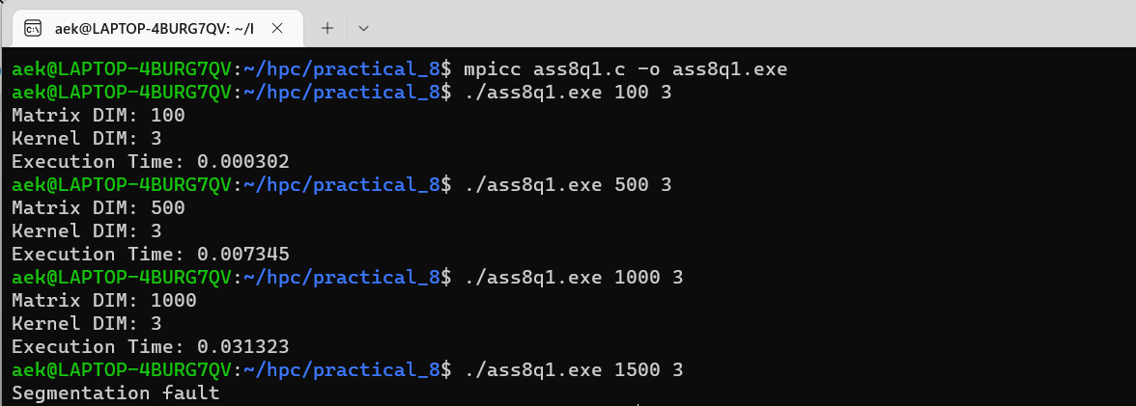

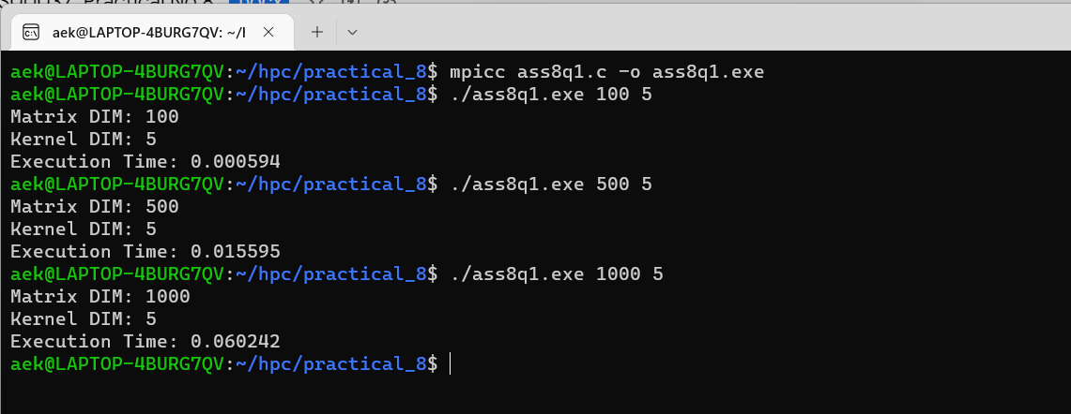

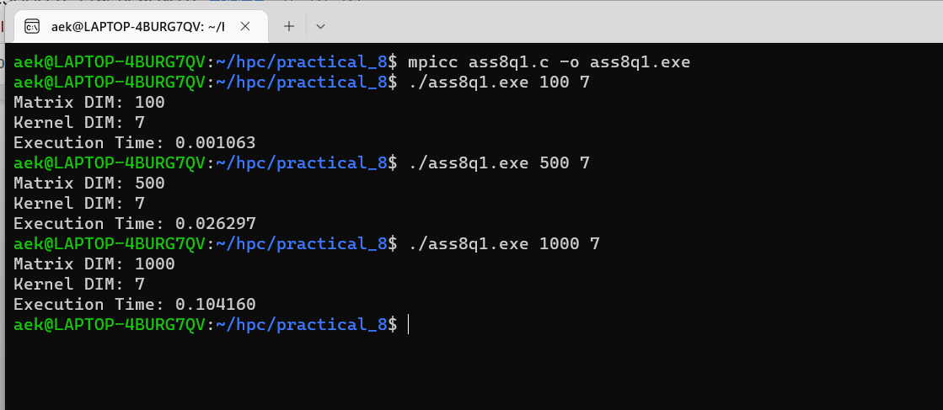

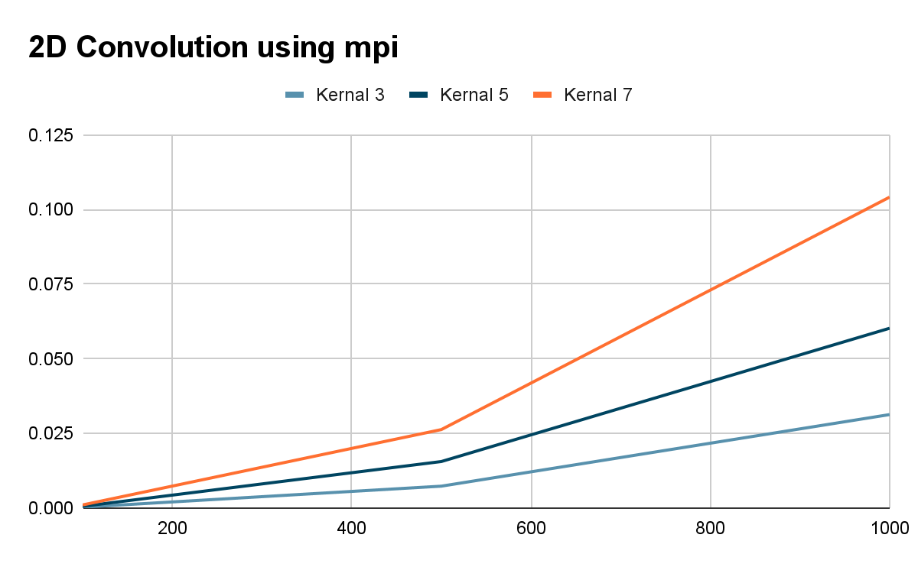

**Problem Statement 2: Implement dot product using MPI. Use a different number of processes and analyze the performance.**

*#include <stdio.h>*

*#include <mpi.h>*

*#include <unistd.h>*

*#include <math.h>*

*#include <time.h>*

*#include <stdlib.h>*

*#define NELMS 100000*

*#define MASTER 0*

*#define MAXPROCS 16*

*int dot_product();*

*void init_lst();*

*void print_lst();*

*int main() {*

*int i,n,vector_x[NELMS],vector_y[NELMS];*

*int prod,sidx,eidx,size;*

*int pid,nprocs, rank;*

*double stime,etime;*

*MPI_Status status;*

*MPI_Comm world;*

*n = 100000;*

*if (n > NELMS) { printf("n=%d > N=%d\n",n,NELMS); exit(1); }*

*MPI_Init(NULL, NULL);*

*world = MPI_COMM_WORLD;*

*MPI_Comm_size(MPI_COMM_WORLD, &nprocs);*

*MPI_Comm_rank(MPI_COMM_WORLD, &pid);*

*int portion = n / nprocs;*

*sidx = pid * portion;*

*eidx = sidx + portion;*

*init_lst(vector_x, n);*

*init_lst(vector_y, n);*

*int tmp_prod[nprocs];*

*for (i = 0; i < nprocs; i++)*

*tmp_prod[i] = 0;*

*stime = MPI_Wtime();*

*if (pid == MASTER) {*

*prod = dot_product(sidx, eidx, vector_x, vector_y, n);*

*for (i = 1; i < nprocs; i++)*

*MPI_Recv(&tmp_prod[i-1], 1, MPI_INT, i, 123, MPI_COMM_WORLD, &status);*

*}*

*else {*

*prod = dot_product(sidx, eidx, vector_x, vector_y, n);*

*MPI_Send(&prod, 1, MPI_INT, MASTER, 123, MPI_COMM_WORLD);*

*}*

*if (pid == MASTER) {*

*for (i = 0; i < nprocs; i++)*

*prod += tmp_prod[i];*

*}*

*etime = MPI_Wtime();*

*if (pid == MASTER) {*

*//print_lst(vector_x,n);*

*//print_lst(vector_y,n);*

*printf("Final Product = %d\n",prod);*

*printf("Time elapsed = %f\n",etime-stime);*

*}*

*MPI_Finalize();*

*}*

*int dot_product(int s,int e, int x[], int y[], int n){*

*int i,prod=0;*

*for (i = s; i < e; i++)*

*prod = prod + x[i] * y[i];*

*return prod;*

*}*

*void init_lst(int *l,int n){*

*int i;*

*for (i=0; i<n; i++) *l++ = i;*

*}*

*void print_lst(int l[],int n){*

*int i;*

*for (i=0; i<n; i++) {*

*printf("%d ", l[i]);*

*}*

*printf("\n");*

*}*

*// end of file*

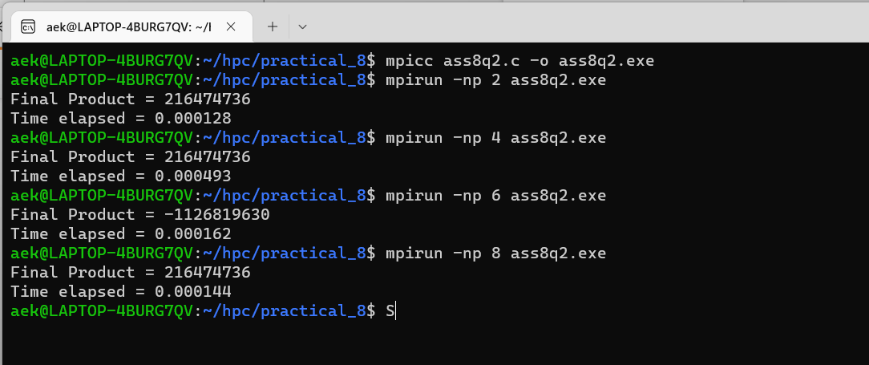

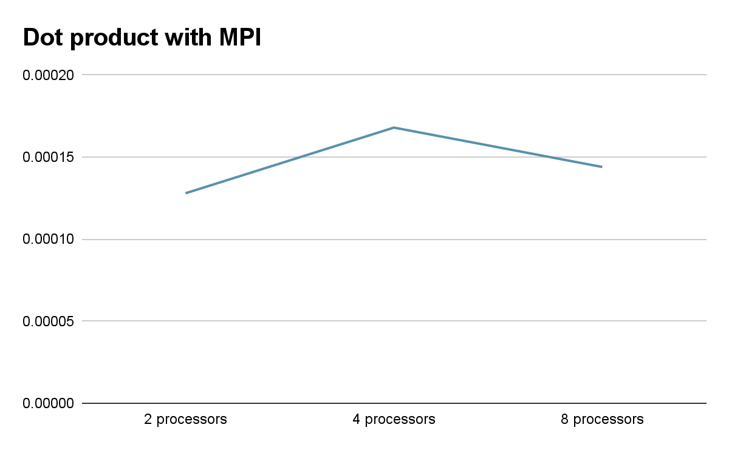

**Problem Statement 3: Implement Prefix sum using MPI. Use a different number of processes and analyze the performance.**

*#include <stdio.h>*

*#include<stdlib.h>*

*#include <math.h>*

*#include "mpi.h"*

*int main(int argc, char* argv[]){*

*int my_rank; /* rank of process */*

*int p; /* number of processes */*

*MPI_Status status ; /* return status for receive */*

*int value;*

*/* start up MPI */*

*MPI_Init(&argc, &argv);*

*/* find out process rank */*

*MPI_Comm_rank(MPI_COMM_WORLD, &my_rank);*

*/* find out number of processes */*

*MPI_Comm_size(MPI_COMM_WORLD, &p);*

*int prefix_arr[p];*

*/* getting input and scatter values */*

*if(my_rank == 0){*

*int i;*

*for(i = 0; i < p; ++i){*

*prefix_arr[i] = i + 1;*

*}*

*}*

*double start = MPI_Wtime();*

*//all call scatter*

*MPI_Scatter(prefix_arr, 1, MPI_INT, &value, 1, MPI_INT, 0, MPI_COMM_WORLD);*

*/\**

*prefix sum:*

*repeat log n times*

*each time, if we are the chosen one, we receve a value from someone and add to ours*

*otherwise, we send to the chosen one*

*\*/*

*int i;*

*int logn = log2(p);*

*for(i = 0; i <= logn; i++){*

*int lower_bound = pow(2,i);*

*int upper_bound = p - lower_bound;*

*if(upper_bound < lower_bound){*

*upper_bound = lower_bound;*

*}*

*if(my_rank < lower_bound){*

*int send = (int) (my_rank + pow(2,i));*

*if(send >= p)*

*continue;*

*printf("%d sending to %d\n", my_rank, (int) (my_rank+pow(2,i)));*

*MPI_Send(&value, 1, MPI_INT, (int) (my_rank+pow(2,i)), 0, MPI_COMM_WORLD);*

*}*

*else if(my_rank >= upper_bound){*

*int recv = (int) (my_rank - pow(2,i));*

*if(recv >= p)*

*continue;*

*int recv_value;*

*printf("%d receving..\n", my_rank);*

*MPI_Recv(&recv_value, 1, MPI_INT, (my_rank - pow(2,i)), 0, MPI_COMM_WORLD, &status);*

*value += recv_value;*

*}*

*else{*

*int send = (int) (my_rank + pow(2,i));*

*int recv = (int) (my_rank - pow(2,i));*

*if(send >= p || recv >= p)*

*continue;*

*printf("%d sending to %d\n", my_rank, (int) (my_rank+pow(2,i)));*

*MPI_Send(&value, 1, MPI_INT, (int) (my_rank+pow(2,i)), 0, MPI_COMM_WORLD);*

*printf("%d receving..\n", my_rank);*

*int recv_value;*

*MPI_Status status;*

*MPI_Recv(&recv_value, 1, MPI_INT, (my_rank - pow(2,i)), 0, MPI_COMM_WORLD, &status);*

*value += recv_value;*

*}*

*}*

*//after algorithm, each processor hols its own prefix sum*

*//we gather at rank*

*int gather[p];*

*MPI_Gather(&value, 1, MPI_INT, gather, 1, MPI_INT, 0, MPI_COMM_WORLD);*

*if(my_rank == 0){*

*double end = MPI_Wtime();*

*printf("Execution Time: %f\n", end - start);*

*}*

*/* shut down MPI */*

*MPI_Finalize();*

*return 0;*

*}*

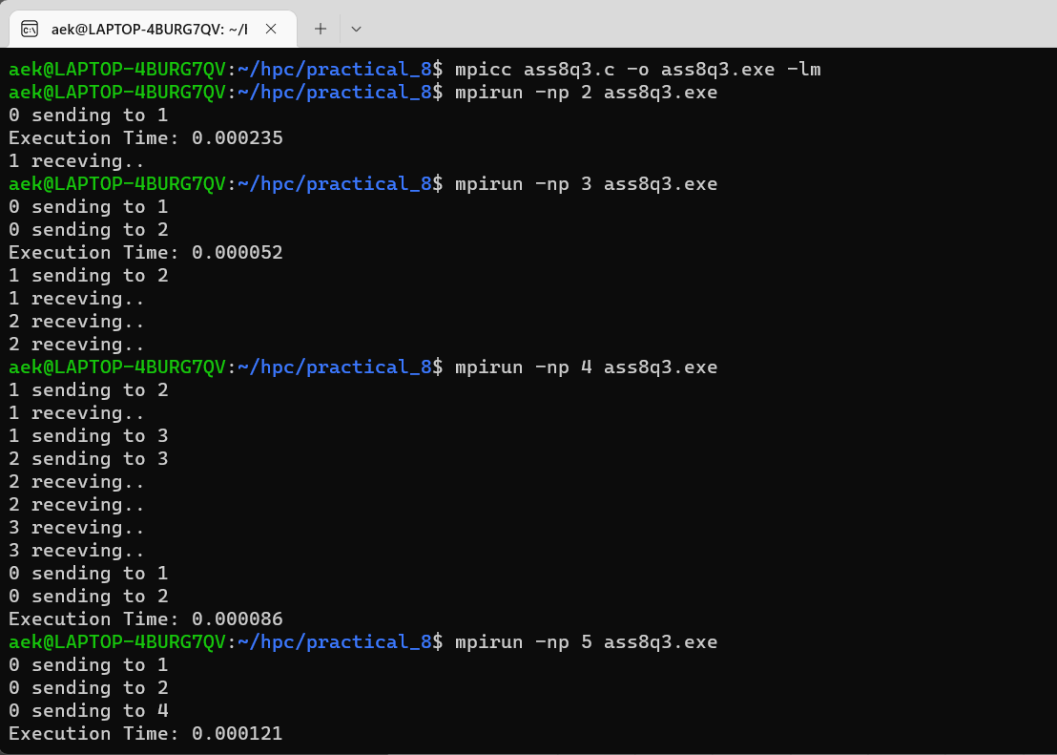

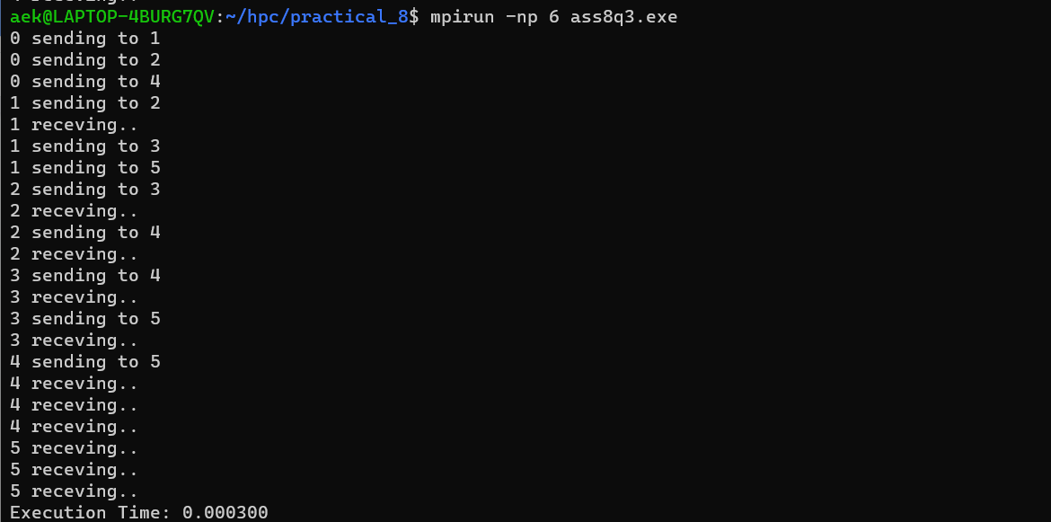

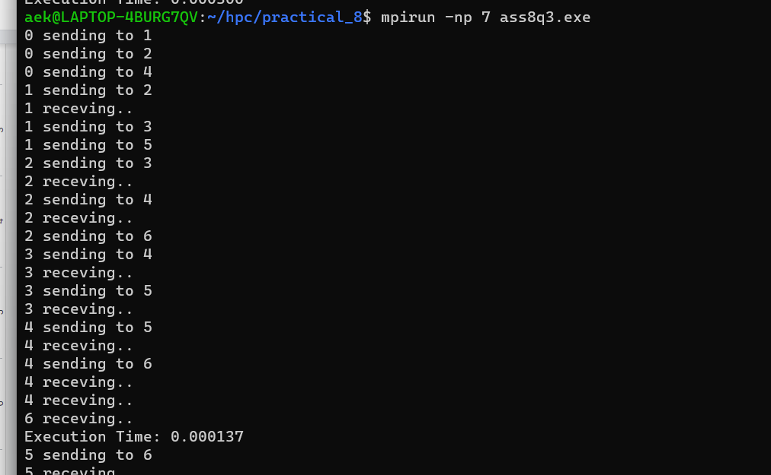

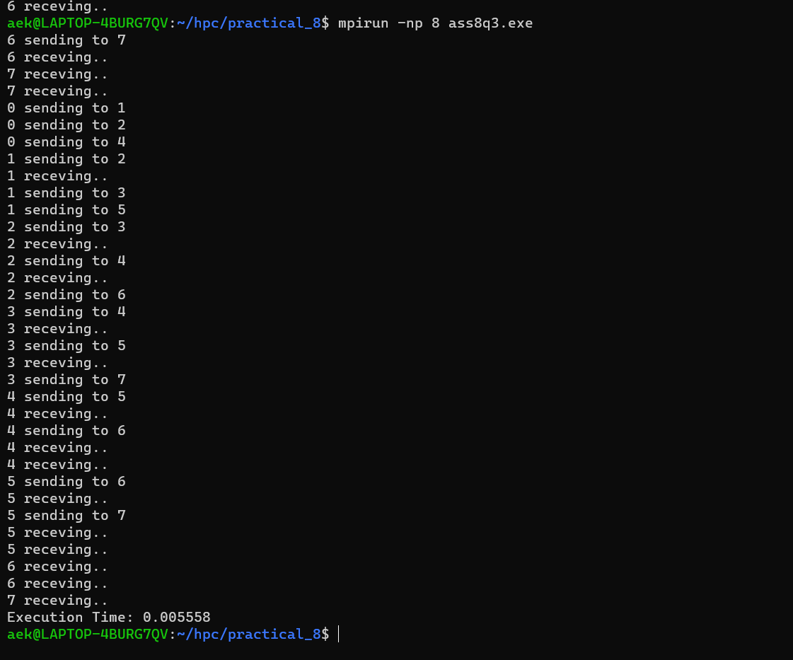

| **Processors** | **Time** |
| --- | --- |
| **2** | **0.000120** |
| **3** | **0.000052** |
| **4** | **0.000086** |
| **5** | **0.000121** |
| **6** | **0.000300** |
| **7** | **0.000137** |
| **8** | **0.005558** |

**Github Link:**

[**https://github.com/OnkarGavali/HPC_Lab/tree/main/Practical_No8**](https://github.com/OnkarGavali/HPC_Lab/tree/main/Practical_No8)